
System Documentation for Online Learner Progress Monitor (OLP-Monitor)
Senior School Edition

December 22, 2025
Northum Tech Academia Ventures
info@northumtech.com

System Documentation for Online Learner Progress Monitor (OLP-Monitor) - Senior School Edition
Version 1.3 – Development Ready Specification with Workflow Diagrams
Date: December 22, 2025

1. Executive Summary
The OLP-Monitor is a cloud-native education management platform designed for Kenya's Competency-Based Curriculum (CBC) Senior School (Grades 10-12). This document provides a comprehensive specification for its development, outlining the system's architecture, features, user roles, data models, operational requirements, and detailed workflow diagrams. The platform will automate administrative tasks, track learner progress in real-time, and provide data-driven insights for stakeholders from the classroom to the national level.
2. System Architecture & Technology Stack
2.1 High-Level Architecture
The system will be built on a microservices-oriented architecture to ensure scalability and maintainability. It will consist of a frontend application, a backend API gateway, several core services, and a shared data layer.
- Frontend: A single-page application (SPA) built with a modern framework (e.g., React, Angular, Vue.js) using TypeScript. It must be responsive, mobile-first, and Progressive Web App (PWA) enabled for offline capabilities in low-bandwidth areas.
- Backend: A set of RESTful APIs built with Node.js (using a framework like NestJS for structure) or a comparable technology.
GraphQL will be used for complex data fetching and analytics dashboards.
- Database: A primary relational database (e.g., PostgreSQL) for structured data like user profiles, assessments, and financial records.
A time-series database extension (like TimescaleDB) will be used for performance analytics.
- Authentication: A stateless authentication mechanism using JSON Web Tokens (JWT) with refresh tokens.
OAuth 2.0 integration must be architected for future Ministry of Education Single Sign-On (SSO).
- Infrastructure: The entire system will be containerized using Docker and orchestrated via Kubernetes on a major cloud provider (AWS/Azure) with data residency in Africa (e.g., Cape Town).
- Deployment will follow a blue-green strategy to ensure zero downtime.

2.2 Core Technology Components
- File Storage: A scalable object storage service (e.g., AWS S3, Google Cloud Storage) for documents, assignments, and media files.
- Caching: An in-memory data store (e.g., Redis) to cache frequently accessed data, such as dashboard metrics and session information, to improve performance.
- Message Queue: A message broker (e.g., RabbitMQ, AWS SQS) for handling asynchronous background tasks like report generation, notification processing, and score calculations.
- Notifications: An integrated notification service capable of sending emails (e.g., SendGrid), SMS (e.g., Twilio), and push notifications (e.g., Firebase Cloud Messaging).

2.3 Security & Compliance
- Data Encryption: All Personally Identifiable Information (PII) must be encrypted at rest (AES-256) and in transit (TLS 1.2+).
- Access Control: A robust Role-Based Access Control (RBAC) system with granular permissions must be implemented.
- Compliance: The system must be fully compliant with the Kenya Data Protection Act. All servers and data must be hosted within Kenya's designated geographical jurisdiction.
- Auditability: All critical actions (e.g., grade changes, payment records, user role modifications) must be logged with details of the user, action, timestamp, and IP address.

3. Core Data Entities & Relationships
This section defines the primary data objects and their relationships. The development team will translate these into a database schema.
Entity Name | Key Attributes | Relationships
User | id, reg_number, role, email, password_hash, is_verified | A User can be a Learner, Teacher, Parent, etc. One-to-one with Learner/Parent profiles.
School | id, name, code, county, sub_county, address, headteacher_id | Has many Learners and Teachers. Headteacher is a User.
Pathway | id, name, code (e.g., STEM, Arts, Social Sciences) | Has many Learning Areas. A Learner belongs to one Pathway.
Learning Area | id, name, code, pathway_id (nullable for core), is_core, strands (JSON), rubrics (JSON) | Belongs to a Pathway (or is Core). Has many Assessments.
Learner | id, user_id, school_id, admission_number, pathway_id, parent_id | Belongs to a School and Pathway. Has a Parent (User). Has many Assessments.
Assessment | id, learner_id, learning_area_id, type, term, year, score_data (JSON), teacher_id | Belongs to a Learner and Learning Area. Created by a Teacher (User).
Examination | id, name, type (Opener/Mid/End), term, year, school_id, learning_area_id | Has many Exam Results.
Exam Result | id, examination_id, learner_id, score, grade | Belongs to an Examination and a Learner.
Financial Transaction | id, learner_id, type, amount, payment_method, reference_number, date | Belongs to a Learner.
Bursary Application | id, learner_id, status, amount_requested, supporting_docs (JSON) | Belongs to a Learner.
Book | id, title, isbn, learning_area_id, total_copies, available_copies | Has many Book Issuance records.
Book Issuance | id, book_id, learner_id, issue_date, return_date, status | Links a Book to a Learner.

4. User Roles & Feature Specifications
4.1 Teacher Dashboard
Purpose: To manage classroom activities, track learner progress, and communicate with stakeholders.
- Landing Page Overview:
  - Widget: "My Classes" - list of assigned classes with student counts.
  - Widget: "Pending Tasks" - count of assessments needing entry, attendance to be marked.
  - Widget: "Recent Notifications" - alerts from the headteacher or system.
- Assessment Management:
  - Formative Entry: A structured interface to select a Learning Area, then navigate its strands and sub-strands. For each student in a class, the teacher inputs a rubric level (1-4) for each indicator.
  - The system must auto-calculate the average score and map it to the corresponding CBC grade upon saving.
  - Summative Entry: Interface to create or select an examination (e.g., "End Term - Mathematics"). The teacher inputs a percentage score (0-100) for each student. The system must auto-assign the correct grade.
- Classroom Tools:
  - Attendance Register: A daily, bulk-updateable list of students to mark Present, Absent, Late, or Excused.
  - Assignment Upload: Ability to upload assignment sheets or resources for a specific class and learning area.
  - Book Issuance: A tool to issue school books to students, updating the inventory in real-time.
- Communication:
  - A feature to send standardized progress messages (e.g., "Please note that your child's performance in Biology has improved") to individual or groups of parents.
- Pathway Feedback: An optional field to provide qualitative feedback and a star rating (1-5) on a learner's suitability for their chosen pathway.

4.2 Student Dashboard
Purpose: To empower learners to track their own academic progress and access learning resources.
- Performance View:
  - Visual graphs (line/bar charts) showing performance trends across terms for all learning areas.
  - A detailed table view of all formative and summative assessments, with scores and grades.
- Resource Center:
  - A section to download resources uploaded by their teachers.(Formats: MP4, links, Docx, Pdf, PPtx or Excel)
- Engagement Tools:
  - Access to participate in aptitude surveys.
  - A feature to anonymously rate their teachers (1-5 stars) on teaching effectiveness.
- Account Management:
  - View the list of books currently issued to them and their due dates.

4.3 Parent Dashboard
Purpose: To provide parents with transparent oversight of their child's academic and financial status.
- Multi-Child View: A tabbed interface to switch between children if more than one is enrolled in the system.
- Academic Progress:
  - Access to their child's performance reports and result slips.
  - View of upcoming assignments and past submissions.
- Financial Management:
  - A clear fee payment history with a visual progress bar showing percentage of total fees paid.
  - A dedicated module to apply for bursaries, including the ability to upload scanned, stamped supporting documents.
- Communication & Feedback:
  - View messages from teachers and the school administration.
  - Access to rate their child's teachers.
- School Calendar: A view of upcoming school events and important dates.

4.4 Head of Institution(Princpal) Dashboard
Purpose: To provide a holistic view and management tools for the entire school.
- School Management:
  - Register and configure the school (logo, offered pathways).
  - Register and verify teachers, Teachers registration data: Name, ID number, Name, TSC number, Contacts and an active e-mail which will be used when sending them activation links via email.
- Academic Oversight:
  - Curriculum progress bars for each learning area, showing the percentage of the curriculum covered, based on the last updated rubric from a specific sub-strand.
  - Performance analytics with comparative graphs for classes and the entire school.
- Administrative Workflows:
  - Bursary Approval: A workflow to review bursary applications, verify attached documents, approve or reject them, and submit approved applications to sponsors.
  - Infrastructure Tracking: A module to create and monitor infrastructure projects (e.g., "Science Lab Construction"), with budget, expenditure, and progress percentage.
- Staff Performance: View aggregated star ratings for teachers, to be used as a data point for promotion recommendations.

4.5 Finance Administrator Dashboard
Purpose: To manage the school's finances and inventory.
- Payment Recording:
  - An interface to manually record fee payments.
  - A field to enter the M-Pesa confirmation code for reconciliation.
- Inventory Management:
  - Books: Track received books, update stock levels, and manage the issuance/return cycle.
  - Capitation: A module to track government capitation funds received and allocated.

4.6 Administrative Office Dashboards (Sub-County, County, National)
Purpose: To provide aggregated data for oversight and strategic decision-making.
- Analytics & Insights: Aggregated performance data displayed via charts, heatmaps, and trend lines across schools, counties, or nationally.
- Oversight Modules:
  - Transfer Management: A system to process and approve learner transfers between schools.
  - Bursary & Capitation Oversight: High-level views of fund disbursement and utilization.
  - School Classification: Tools to classify and tag schools based on performance, infrastructure, or pathway focus (e.g., "STEM Center of Excellence").

5. Key Business Logic & Workflows
5.1 Student Registration & Pathway Assignment
- Initiation: Parent submits required documents to the Headteacher.
- Account Creation: Headteacher creates a User account and a Learner profile.
- Pathway Selection: Headteacher selects one of the three pathways (STEM, Arts, Social Sciences) for the learner as guided by the KJSEA Results.
- Subject Validation: The system must enforce the CBE rule: the learner's profile must include the 4 core learning areas and exactly 3 electives from the selected pathway. The UI must prevent saving if this rule is violated.
- Finalization: Headteacher confirms registration. The system sends login credentials to the parent and assigns the learner to the appropriate classes.

5.2 Assessment Synthesis
- Entry: Teacher enters formative and summative scores throughout the term.
- Synthesis: At the end of the term, the system must automatically synthesize these scores into a single result slip.
- Result Slip Display: The slip must display:
  - A column for the average formative score per learning area.
  - A column for the summative exam score per learning area.
  - The final, calculated grade and score for the term.
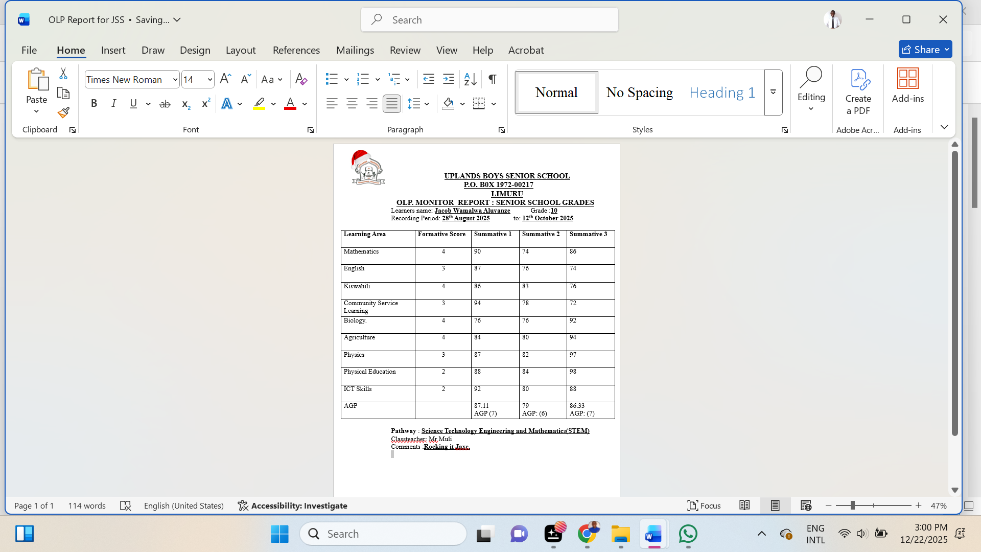

- Availability: The synthesized result slip is instantly available on the Student, Parent, and Teacher dashboards.

5.3 Bursary Application & Approval
- Application: Parent submits a bursary application via their dashboard, uploading all necessary documents.
- Finance Review: The Finance Administrator receives a notification, reviews the application, and attaches the learner's outstanding fee balance.
- Headteacher Approval: The application is routed to the Headteacher for final review. The Headteacher can approve or reject, providing comments.
- Submission: If approved, the system automatically packages the application and submits it to the designated sponsor's portal or email. The parent is notified of the outcome at each stage.

6. Key Workflow Diagrams
This section provides visual diagrams for the most critical system workflows.

6.1 Student Registration & Pathway Assignment Flow
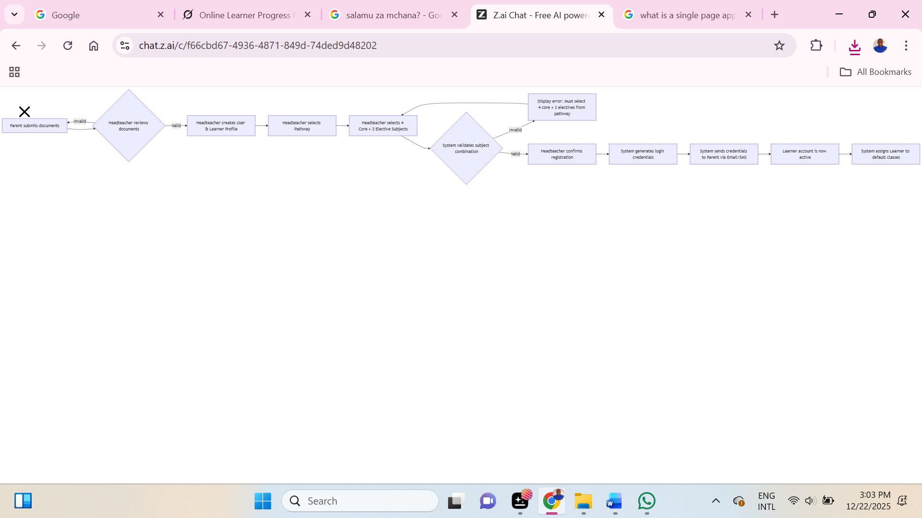
This flowchart details the process from a parent's initial inquiry to the final activation of a learner's account.

Key Logic & Validation Points:
- The system must prevent a Headteacher from saving a learner's subject selection if it does not contain exactly 4 core learning areas and exactly 3 electives from the chosen pathway.
- An email/SMS notification must be sent to the parent upon successful registration, containing the temporary password and login instructions.

6.2 Assessment Entry & Result Synthesis Sequence
This sequence diagram shows the interaction between the Teacher, System, and Database during the assessment process, culminating in the automatic generation of a result slip.

Key Logic & Validation Points:
- The synthesis process must run automatically at the end of each term.
- The result slip must clearly separate the average formative score, the summative score, and the final grade for each learning area.
- The system must be able to handle cases where a summative exam score is missing (e.g., student absent) and reflect this on the result slip.

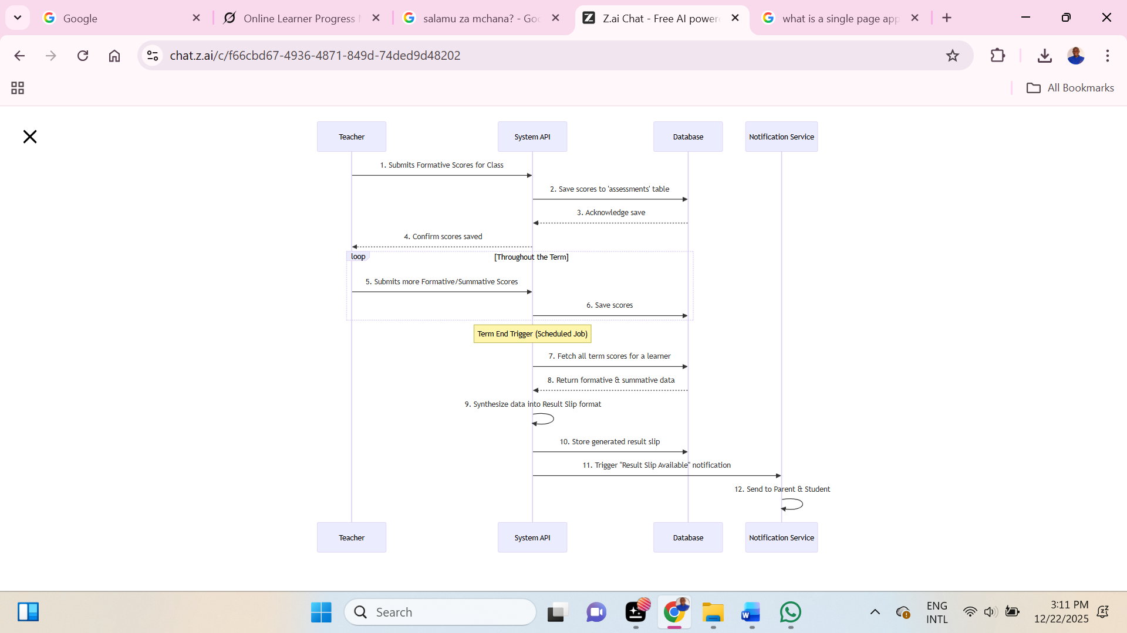

Bursary Application Swimlane Diagram
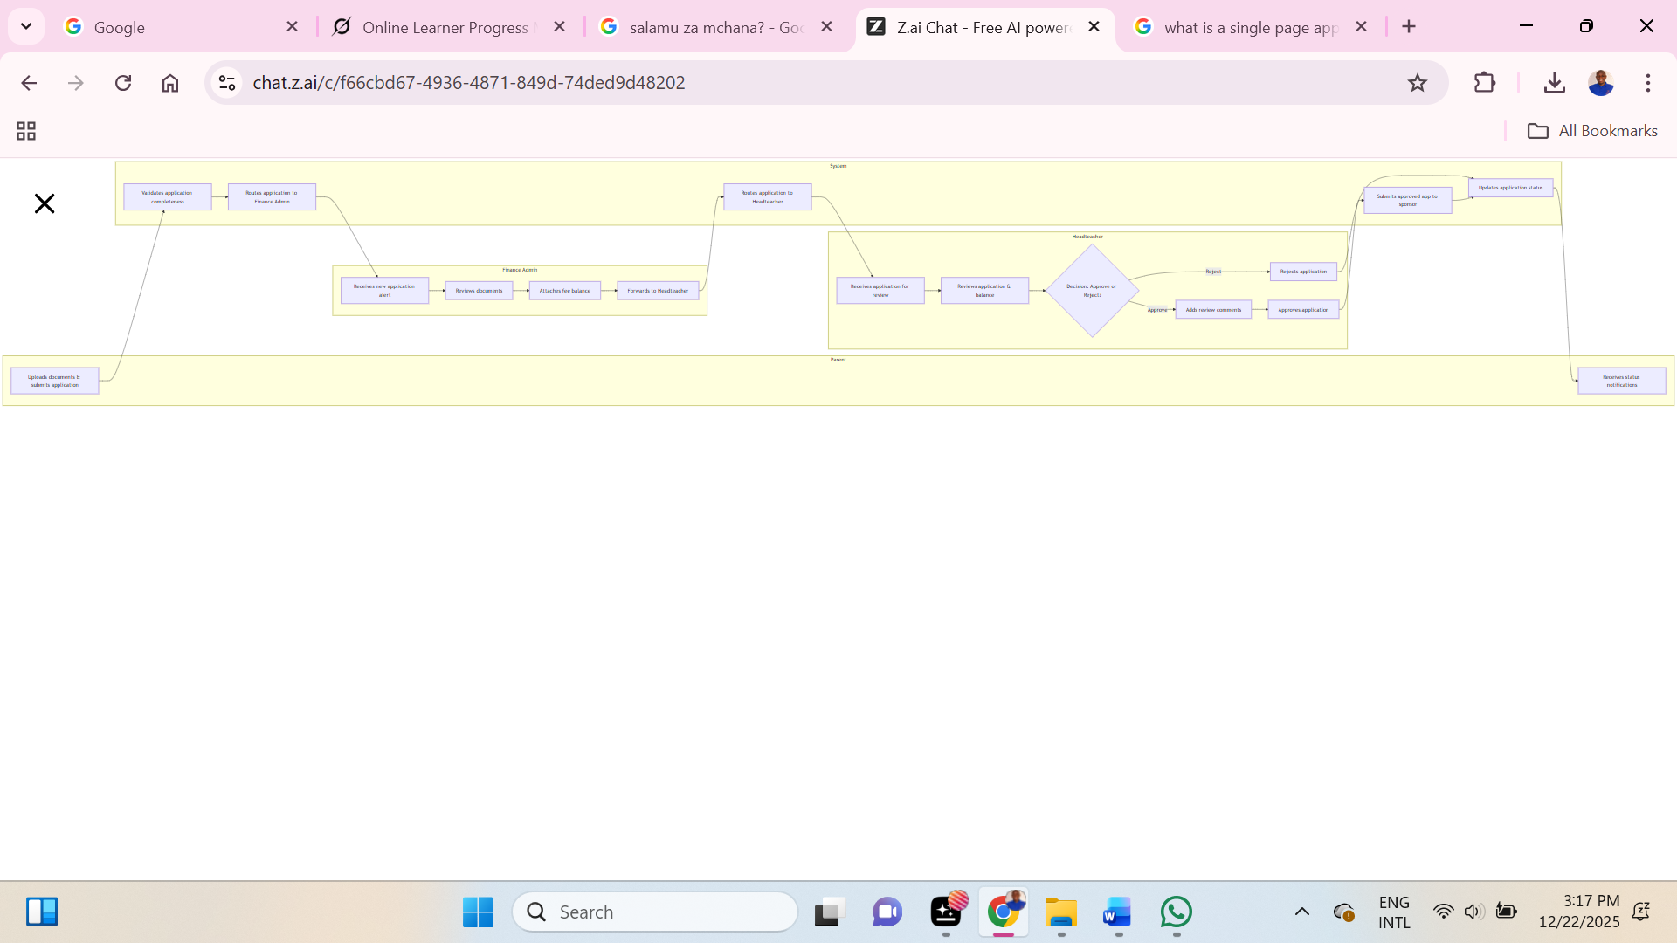
This diagram clarifies the roles and responsibilities in the bursary application process, showing the handoffs between the Parent, Finance Admin, Headteacher, and the System.

Key Logic & Validation Points:
- The system must prevent a parent from submitting an application if required documents are missing.
- The Finance Admin must be able to view the learner's current fee balance before attaching it to the application.
- The system must log all state changes (pending -> under review -> approved/rejected) in the audit trail.
- The submission to the sponsor must only occur after the Headteacher's final approval.

6.4 Fee Payment & M-Pesa Reconciliation Sequence
This diagram illustrates the process of recording a payment and verifying it with the external M-Pesa API.
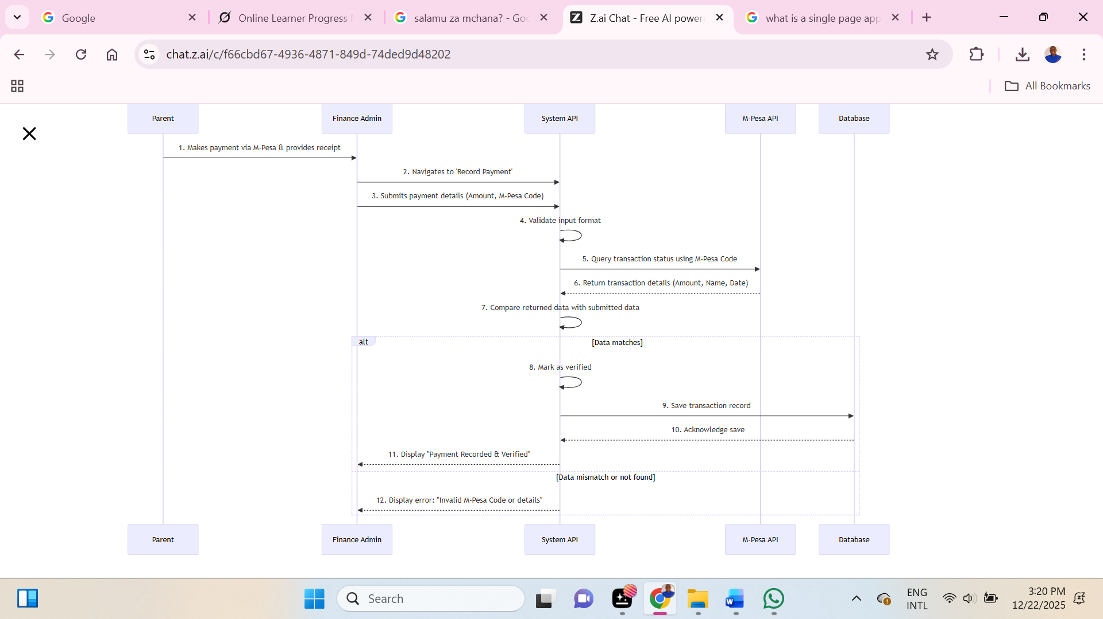
Key Logic & Validation Points:
- The M-Pesa confirmation code must be unique per transaction.
- The system must verify the transaction amount and date with the M-Pesa API before finalizing the record.
- The system must handle API errors from M-Pesa gracefully and provide clear feedback to the Finance Admin.

7. Non-Functional Requirements
Category | Requirement
Performance | Page load time < 2 seconds. API response time < 500ms for 95th percentile.
Scalability | The architecture must support scaling to handle 1,000+ schools and 1.2M+ learners by 2026.
Availability | 99.9% uptime service level agreement (SLA).
Usability | Mobile-first design. Interface must be available in English and Kiswahili. Must comply with WCAG 2.1 AA accessibility standards.
Security | All PII encrypted. Regular security audits. Penetration testing before major releases.
Data Retention | All academic records must be retained for a minimum of years.

System Documentation Developed by:
Tr. Stephen N. Mwaura
Program Director,
Northum Tech Academia Ventures Limited.

